Racine county bar association
Serving Racine Since 1875
Board Officers: Board of Governors:
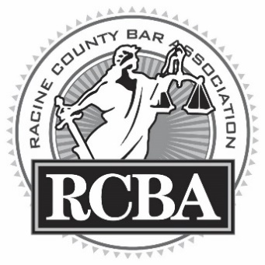
President Peter Wyant Kelly Mould
President-Elect Jennifer Hemmer Patrick Cafferty
Past-President Matthew Johnson Ray Gamez
Secretary Carrie Michelson Joe Kremkoski
Treasurer Eric Markusen Devin Stasek
Technology Brian Dimmer Jillian Scheidegger

www.racinelawyers.com
info@racinelawyers.com

Thank you for your interest in joining or renewing your membership with the Racine County Bar Association for the 2018 year (June 2018 to May 2019). The RCBA serves to benefit both the County of Racine and its members. Here are some of the many reasons why you should become a member of the RCBA:

- We organize four business/dinner meetings each year. Traditionally, these dinners occur in May, September, November, and March. We have enjoyed local food from restaurants such as Corner House, O’Dennis!, Envi, Salute, Reef Point Brew Pub, Mike & Angelos, and more. Your membership fee includes the cost of these great meals!

- We organize 4-CLE opportunities in conjunction with our dinner meetings (usually 1 CLE per dinner meeting) as well as a 3-credit Ethics CLE in December of each year.

- We connect you with other practicing attorneys, judges, and the Racine Community. We create a profile for you on our website, www.racinelawyers.com. We send out notices of upcoming meetings, events, and job openings. Membership with the RCBA will bolster your resume and your online profiles (e.g. Avvo.com).

- We are developing new opportunities for young lawyers to connect both with each other as well as established attorneys and judges. We hope to schedule a number of happy hour social events throughout the year. Whether you’re a young attorney or just young at heart, these are great events to attend and free with your membership.

- We plan additional social events during the year, which have in the past included our annual golf-outing/picnic, a Brewers game trip to Miller Park, and our winter social event.

- We organize and hold a Call of the Calendar, to memorialize and celebrate the lives of attorneys in the Racine County community who have passed away.

- We volunteer in the Racine community, such as Law Day, as well as other public speaking opportunities. We also hold judicial polls to advise the community in upcoming elections

2018-2019 RCBA Membership Application Form
Applicant Name:
Firm/Address:
Phone/Fax:
Email/website:
Areas of Practice:
Year Admitted to Wisconsin Bar:
Years RCBA Member:
Years in Practice | Annual Fee
Less than 2 years | $35
2 to 5 | $70
More than 5 | $80
- 50 or more | waived

Please send this application form and your annual dues to:

Racine County Bar Association
Attn: Eric J. Markusen, Treasurer
P.O. Box 085746
Racine, WI 53408

If you have further questions about the RCBA membership form, dues, or the benefits of being a RCBA member, please contact Eric Markusen, RCBA Treasurer, at ejm@wislegalteam.com or at 262-619-9000.

