CHILD WELFARE LAW
(CHIPS and TPRs)
ATTORNEY TRAINING
NOVEMBER 11, 2016, 8:00 A.M. TO 5:00 P.M.
KENOSHA COUNTY CENTER, 19600 HIGHWAY 50, BRISTOL, WI.
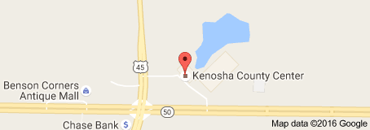

REGISTRATION FORM

_______________________________________________
Name: First Last

_______________________________________________
E-mail Address:

_______________________________________________
Organization / Firm

Your Primary Focus of Practice:

O Family

O Criminal

O Other ________________

Primary County of Practice:

O Kenosha

O Racine

O Walworth

O Other ________________

The purpose of this training is to familiarize new attorneys with the nuts and bolts of Child Welfare Law and to revitalize the interest of current practitioners. This training will be beneficial to people who have never practiced Child Welfare Law, as well as those who have practiced for years. We will address Child Welfare Law from the detention of the child(ren), initial plea, discovery, fact-finding hearing, dispositional reports and orders and post –dispositional hearings.

A presentation on Termination of Parental Rights cases will be incorporated as well.

There will be breakout sessions in the afternoon moderated by individuals practicing child welfare law in each of the three counties

A breakfast of coffee and donuts will be provided in the morning courtesy of The Kenosha County Bar Association

The CLE program will be free, but there will be a $30 fee for materials and lunch. Lunch will be served at the facility as we will be having a “working lunch” in order to cover the materials in the time allotted. The number of CLE’s has not yet been determined.

Please return your completed registration form to Judge Jason A. Rossell at Jason.Rossell@wicourts.gov No later than November 4, 2016.

Please remit your $30 fee to: The Kenosha County Bar Association
c/o David Hughes
6301 Green Bay Road
Kenosha, WI. 53142

Checks should be made out to The Kenosha County Bar Association
If you have any questions please contact Tricia Riley at 262-653-2486

